# Types of Shapes

The following shape approximate a 2D region. A region consists of one or more contour. When the region contains multiple contours, the contours must not overlap. In the example below (Multi), one contour is embedded within the hole of another contour, but the two contours do not overlap because the hole is not part of the contour.

Each contour has two components: An *external* and a list of *holes*. In addition, the *convex hull* of a contour allows for the identification of relationships between crescent shapes contours and contours partially surrounded by the crescent.

|  |  |  |  |
| --- | --- | --- | --- |
|  |  |  |  |
| **Simple** | **Cove** | **Hollow** | **Archipelago** |
|  |  |  |  |
| **External** | **External** | **External** | **External** |
|  |  |  |  |
| **Convex Hull** | **Convex Hull** | **Convex Hull** | **Convex Hull** |
|  |  |  |  |
|  |  | **Hole** | **Hole** |
|  |  |  |  |
|  |  |  | **Island** |

Islands can be treated as separate contours for determining relationships

|  |  |  |  |  |
| --- | --- | --- | --- | --- |
|  | = |  | + |  |

# 2D Relationship Matrix (DE-9IM)

DE-9IM is used to describe the spatial relations between two geometries in two-dimensions. The DE-9IM model is based on a 3×3 intersection matrix with the form below, where ***dim*** is the dimension of the intersection of the interior (***I***), boundary (***B***), and exterior (***E***) of geometries a and b:

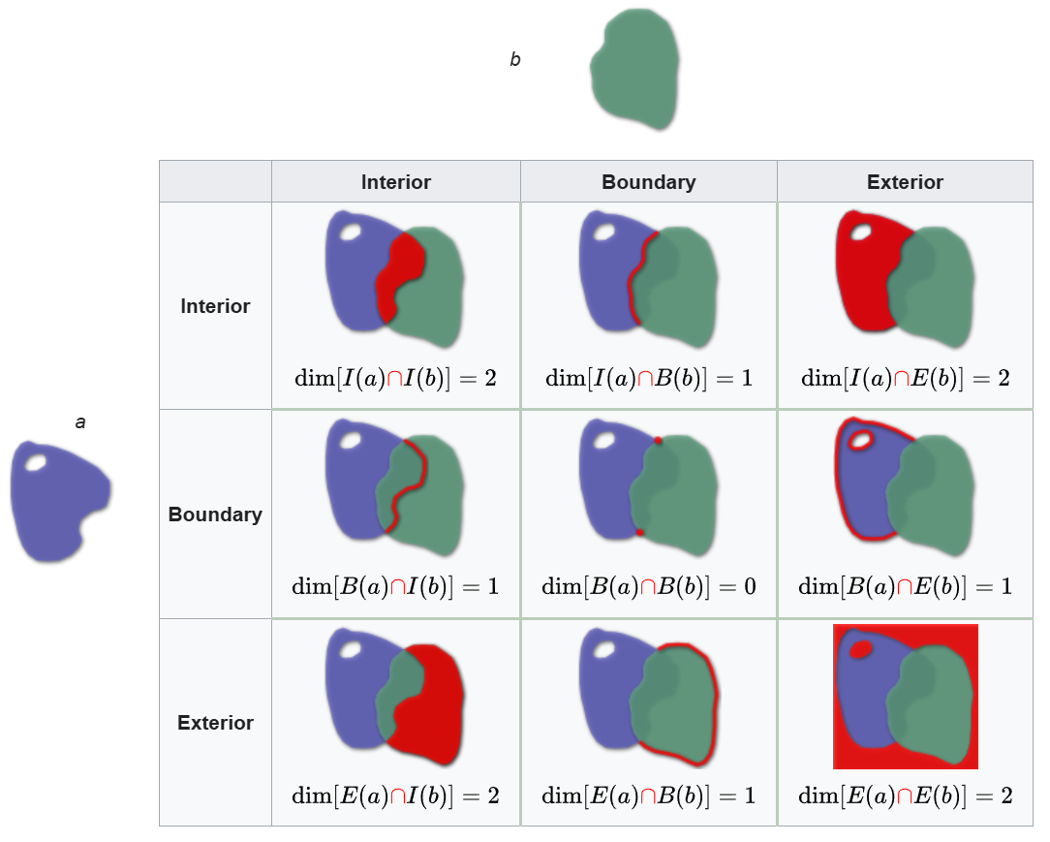

Some examples of defined relationships are:

|  |  |  |
| --- | --- | --- |
| **Name** | **DE-9IM** | **Meaning and definition** |
| **Disjoint** |  | *a* and *b* have no points in common. |
| **Overlaps** |  | *a* overlaps *b*: they have some but not all points in common. |
| **Within** |  | *a* lies in the interior of *b*. |

Note:

* All mask string codes end with *. This is because EE is trivially true, and thus provides no useful information.
* The relationships between external contours of (*a* and *b* with their holes filled) or convex hulls are only specified where necessary to distinguish relationships.
* The geometrical relations between 3D structures must be inferred by combining the relationships for the contours on each slice.

# Relationship Types and Definitions

***region a***

***region b***

***intersection of a & b***

# Disjoint Relations

## Surrounds/ Embeds Transitive

***a*** and ***b*** have no interior points in common, and with holes filled ***b*** lies in the interior of ***a***.

|  |  |  |
| --- | --- | --- |
|  | **Region** | **Exterior** |
|  | |  |  | | --- | --- | | Surrounds | Embeds | |  |  | |

### **Metrics**

Distances between the surrounded and surrounding shape.

## Shelters / Sheltered Transitive

***a*** and ***b*** have no points in common, but the *Convex Hull* of ***a*** contains ***b***.

|  |  |  |
| --- | --- | --- |
|  | **Region** | **Hull** |
|  | |  |  | | --- | --- | | Shelters | Sheltered | |  |  | |

### **Metrics**

Distances between the sheltered island and surrounding shape.

## Fully Disjoint Symmetric

***a*** and ***b*** have no points in common.

|  |  |  |
| --- | --- | --- |
|  | **Region** | **Hull** |
|  |  |

### **Metrics**

None

# Borders *Symmetric*

The exterior boundaries of ***a*** and ***b*** have more than one point in common, but their interiors do not intersect.

|  |  |  |
| --- | --- | --- |
|  | **Region** | **Exterior** |
|  |  |

### **Metrics**

Ratio of the length of overlaping exterior borders to the average length of the two exterior perimeters:

Where:

is the length of the perimeter that and have in comon.

is the exterior perimeter of *a.*

# Interior Borders / Confines

The interior boundary of one shape ***a*** and the exterior boundary of another shape ***b*** have more than one point in common, but their interiors do not intersect.

|  |  |  |
| --- | --- | --- |
|  | **Matrix** | **Exterior** |
|  | |  |  | | --- | --- | | Interior Borders | Confines | |  |  | |

### **Metrics**

Ratio of the length of overlaping interior border to the average length of the relevant perimeter (exterior or hole):

Where:

is the perimeter of the relevant hole in *a*

is the exterior perimeter of *b*

is the length of the perimeter that and have in comon.

# Overlaps *Symmetric*

***a*** overlaps ***b***: both have some but not all points in common.

|  |  |
| --- | --- |
| A colorful drawing of a yellow blue and green object  Description automatically generated with medium confidenceA cartoon of a hat  Description automatically generatedA colorful circle with a yellow and blue circle  Description automatically generatedA blue yellow and green circle  Description automatically generatedA blue green yellow and orange circle  Description automatically generated | **Region** |
|  |

### **Metrics**

Ratio of the area of overlap to area of both:

# Partition / Incorporates *Transitive*

All points of ***a*** lie in the interior of ***b***, no points of ***a*** lie in the exterior of ***b***, some points in ***b*** are exterior to ***a***, and the boundaries of ***a*** and ***b*** have more than one point in common.

|  |  |
| --- | --- |
|  | **Region Test** |
| |  |  | | --- | --- | | Partitions | Incorporates | |  |  | |

### **Metrics**

Ratio of the area of overlap to area of the larger shape:

# Contains / Within *Transitive*

All points of ***a*** lie in the interior of ***b***, no points of ***a*** lie in the exterior of ***b***, some points in ***b*** are *exterior to* ***a****, and the boundaries of* ***a*** *and* ***b*** *do not intersect.*

|  |  |
| --- | --- |
|  | **Region** |
| |  |  | | --- | --- | | Within | Contains | |  |  | |

### **Metrics**

Distances between the exterior of ***a*** and the boundary of ***b***. (For Within, ***a*** & ***b*** reversed for Contains).

# Equals *Symmetric, Transitive*

The interiors of ***a*** and ***b*** intersect and no part of the interior of one geometry intersects the exterior of the other.

|  |  |
| --- | --- |
|  | **Region** |
|  |

### **Metrics**

None

# 3D Conversion

* The relationships on each slice of a structure can be combined using *OR* logic to get the relationship for the 3D structure.
* For the beginning and ending slices of a structure the entire contour must be treated as a boundary. The structure does not have an interior on these slices. In this case the “*Interior*” relations become “Boundary” relations.

|  |  |  |  |  |  |  |  |  |  |  |  |  |  |  |  |  |  |  |  |  |  |  |  |  |  |  |  |  |  |  |  |  |  |
| --- | --- | --- | --- | --- | --- | --- | --- | --- | --- | --- | --- | --- | --- | --- | --- | --- | --- | --- | --- | --- | --- | --- | --- | --- | --- | --- | --- | --- | --- | --- | --- | --- | --- |
| |  |  |  |  | | --- | --- | --- | --- | |  | **Interior** | **Interior** | **Exterior** | | **Interior** |  |  |  | | **Boundary** |  |  |  | | **Exterior** |  |  |  | | |  |  |  |  | | --- | --- | --- | --- | |  | **Interior** | **Interior** | **Exterior** | | **Interior** |  |  |  | | **Boundary** |  |  |  | | **Exterior** |  |  |  | |
| Structure ***a*** ends, but structure ***b*** continues. | Structure ***b*** ends, but structure ***a*** continues. |

|  |  |  |  |  |  |  |  |  |  |  |  |  |  |  |  |  |
| --- | --- | --- | --- | --- | --- | --- | --- | --- | --- | --- | --- | --- | --- | --- | --- | --- |
| |  |  |  |  | | --- | --- | --- | --- | |  | **Interior** | **Interior** | **Exterior** | | **Interior** |  |  |  | | **Boundary** |  |  |  | | **Exterior** |  |  |  | |
| Both structure ***a*** and structure ***b*** end on the same slice. |

### **Identifying Relationships**

If ***a*** is always the larger of the two structures, then the relationships: Embeds, Sheltered, Confines, and Within are not possible. The remaining relationships are: Disjoint, Shelters, Surrounds, Borders, Interior Borders, Overlaps, Partition, Contains, and Equals.

|  |  |  |  |  |  |  |
| --- | --- | --- | --- | --- | --- | --- |
| **Relationship** | **Hull** | | **Exterior** | | **Region** | |
| Disjoint |  | FF*FF**** |  | FF*FF**** |  | FF*FF**** |
| Shelters |  | T***F*F** |  | FF*FF**** |  | FF*FF**** |
| Surrounds |  | T***F*FF* |  | T***F*FF* |  | FF*FF**** |
| Borders |  | FF*FT**** |  | FF*FT**** |  | FF*FT**** |
| Interior Borders |  | T*T*F*FF* |  | T*T*F*FF* |  | FF*FT**** |
| Overlaps |  |  |  |  |  | TTTT*TTT* |
| Partition |  |  |  |  |  | T*T*T*FF* |
| Contains |  |  |  |  |  | T*T*F*FF* |
| Equals |  |  |  |  |  | T*F**FFF* |

# Summary

|  |  |  |  |
| --- | --- | --- | --- |
| **Relationship** | **Hull Test** | **Exterior Test** | **Region Test** |
| Disjoint | FF*FF**** | FF*FF**** | FF*FF**** |
| Shelters | T***F*F** | FF*FF**** | FF*FF**** |
| Surrounds |  | T***F*F** | FF*FF**** |
| Borders |  | FF*FT**** | FF*FT**** |
| Interior Borders |  | T***T**** | FF*FT**** |
| Partitions |  |  | TTTT*TTT* |
| Incorporates |  |  | T*T*T*FF* |
| Within |  |  | T*T*F*FF* |
| Contains |  |  | T*F**FFF* |
| Overlaps |  |  | FF*FF**** |
| Equals |  |  | FF*FF**** |

Convert each test string into two binary number:

1. An ignore mask (0 indicates ignored):
   1. Replace ‘*’ with ‘0’
   2. Replace ‘F’ and ‘T’ with ‘1’
   3. Convert string to a binary integer int(string, 2)
2. A value (Binary number)
   1. Replace ‘*’ with ‘0’
   2. Replace ‘F’ with ‘0’
   3. Replace ‘T’ with ‘1’
   4. Convert string to a binary integer int(string, 2)

|  |  |  |
| --- | --- | --- |
| **Relationship** | **Masks and Values** | |
| Disjoint | *Mask* | (110110000, 110110000, 110110000) |
| *Value* | (000000000, 000000000, 000000000) |
| Shelters | *Mask* | (110110000, 110110000, 100010100) |
| *Value* | (000000000, 000000000, 100000000) |
| Sheltered | *Mask* | (110110000, 110110000, 101010000) |
| *Value* | (000000000, 000000000, 100000000) |
| Surrounds | *Mask* | (110110000, 100010110, 0) |
| *Value* | (000000000, 100000000, 0) |
| Embeds | *Mask* | (110110000, 101011000, 0) |
| *Value* | (000000000, 100000000, 0) |
| Borders | *Mask* | (110110000, 110110000, 0) |
| *Value* | (000010000, 000010000, 0) |
| Confines | *Mask* | (110110000, 101010110, 0) |
| *Value* | (000010000, 101000000, 0) |
| Exsects | *Mask* | (110110000, 101011111, 0) |
| *Value* | (000010000, 100000100, 0) |
| Partitions | *Mask* | (101011100, 0, 0) |
| *Value* | (100010100, 0, 0) |
| Incorporates | *Mask* | (101010110, 0, 0) |
| *Value* | (101010000, 0, 0) |
| Within | *Mask* | (101011100, 0, 0) |
| *Value* | (100000100, 0, 0) |
| Contains | *Mask* | (101010110, 0, 0) |
| *Value* | (101000000, 0, 0) |
| Overlaps | *Mask* | (111101110, 0, 0) |
| *Value* | (111101110, 0, 0) |
| Equals | *Mask* | (101001110, 0, 0) |
| *Value* | (100000000, 0, 0) |

Properties

The spatial predicates have the following properties of binary relations:

**symmetric**

Equals, Overlaps, Disjoint, Borders

A relation is **symmetric** if for all a and b. For example, if ***a*** *Equals* ***b*** then ***b*** *Equals* ***a***.

**transitive**

Equals, Contains, Within, Shelters, Sheltered, Surrounds, Embeds.

A relation is **transitive** if whenever, and then . For example, if ***a*** *Contains* ***b*** and ***b*** *Contains* ***c*** relation, then ***a*** *Contains* ***c***.

|  |  |  |  |  |
| --- | --- | --- | --- | --- |
| **Relationship** | **Symmetric** | **Transitive** | **Complement** | **Link Name** |
| *Disjoint* | *Yes* | *No* | *Disjoint* | *NA* |
| Shelters | No | Yes | Sheltered | Shelter |
| Sheltered | No | Yes | Shelters | Shelter |
| Surrounds | No | Yes | Embeds | Island |
| Embeds | No | Yes | Surrounds | Island |
| Borders | Yes | No | Borders | Borders |
| Confines | No | No | Exsects | Cut-out |
| Exsects | No | No | Confines | Cut-out |
| Partitions | No | No | Incorporates | Group |
| Incorporates | No | No | Partitions | Group |
| Within | No | Yes | Contains | Expansions |
| Contains | No | Yes | Within | Expansions |
| Overlaps | Yes | No | Overlaps | Overlaps |
| Equals | Yes | Yes | Equals | Equals |

|  |  |  |
| --- | --- | --- |
| **Relationship** | **Metrics** | |
| Surrounds | Distances between the surrounded and surrounding shape. | |
| Embeds |
| Shelters | Distances between the sheltered island and surrounding shape. | |
| Sheltered |
| Disjoint | *N/A* | |
| Exterior Borders | Ratio of the length of overlap to the length of the exterior perimeter. | Where:  is the perimeter of *a*  is the exterior perimeter of *a*  is the perimeter of the relevant hole in *a*  is the length of the perimeter of *a* |
| Interior Borders | Ratio of the length of overlap to the length of the relevant hole perimeter. |
| Overlaps | Ratio of the area of overlap to area of both: | |
| Partitions | Ratio of the area of overlap to area of the larger shape: | |
| Incorporates |
| Contains | Distances between the exterior of ***a*** and the boundary of ***b***. (For Within, ***a*** & ***b*** reversed for Contains). | |
| Within |
| Equals | *N/A* | |